1. **Create table kategori**

|  |
| --- |
| create table kategori(  id serial primary key,  nama varchar(50),  status_aktif varchar(20)  );  select * from produk |

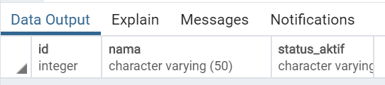

1. Create table produk

|  |
| --- |
| create table produk(  id serial primary key,  nama_produk varchar(50) not null,  deskripsi TEXT,  harga_produk money,  stok SMALLINT,  status_aktif boolean  );  select * from produk |

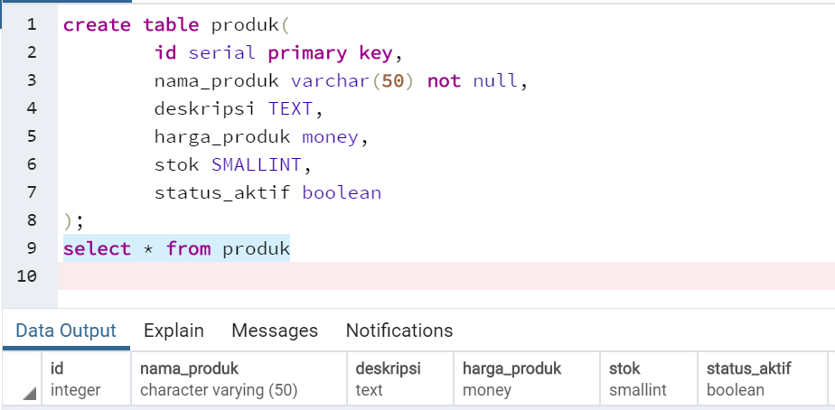

1. Alter table

* Created_date

|  |
| --- |
| ALTER TABLE  produk  add column  created_date date default current_date    select * from produk; |
|  |

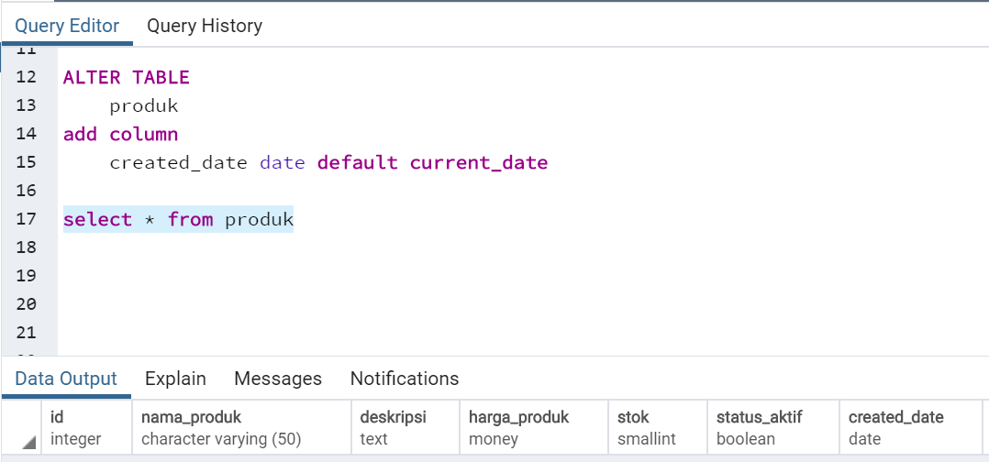

* Modified_date

|  |
| --- |
| ALTER TABLE  produk  add column  modified_date date    select * from produk |

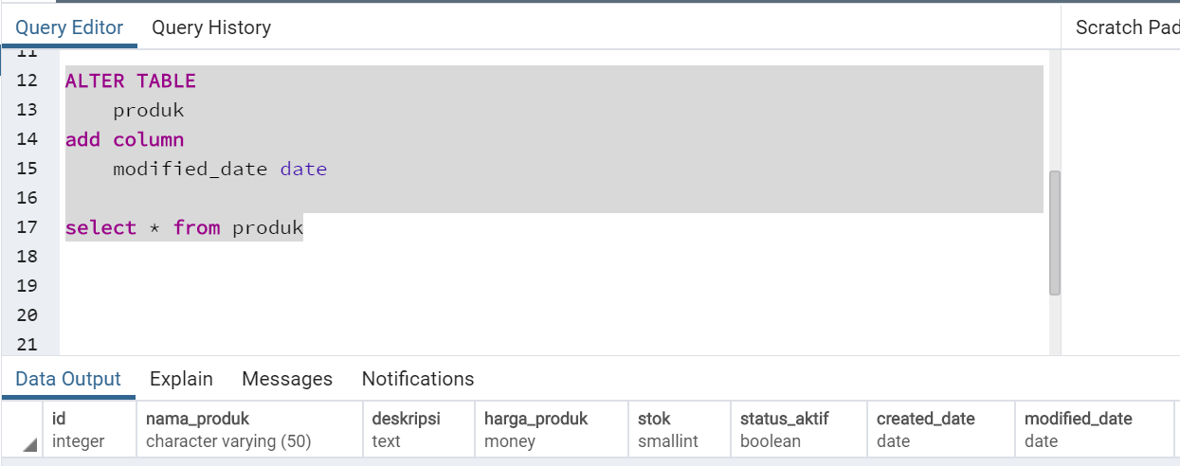

* Add constraint

|  |
| --- |
| ALTER TABLE  produk  add constraint  prod_mod_date check (modified_date >= current_date) |

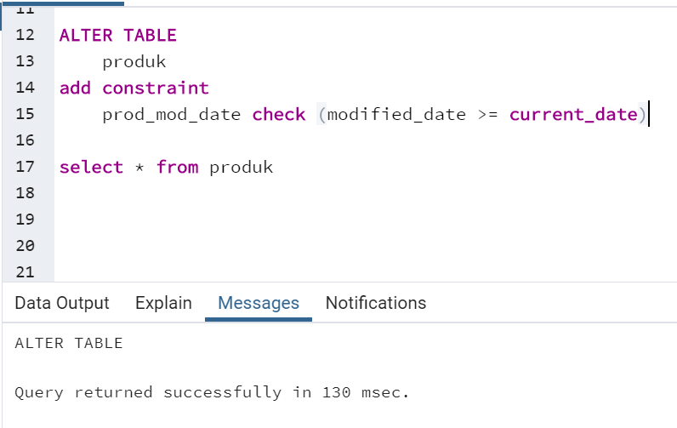

* Id_kategori

|  |
| --- |
| ALTER TABLE  produk  add column  id_kategori int REFERENCES kategori(id) |

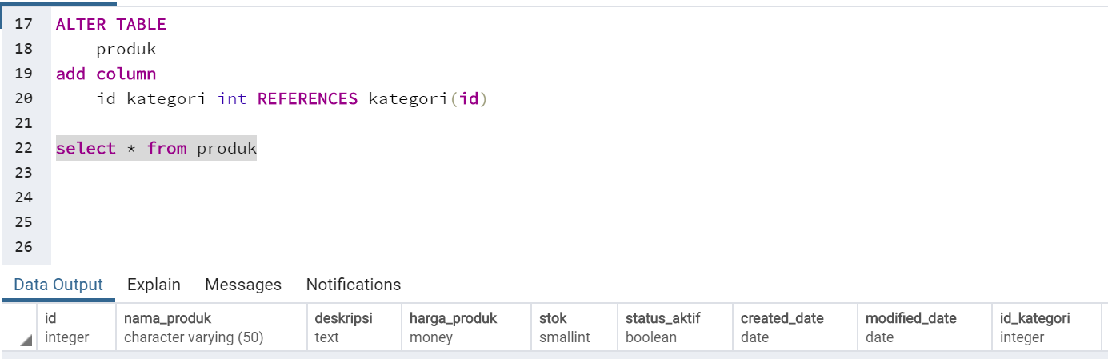

* Drop Status Aktif

|  |
| --- |
| ALTER TABLE  produk  DROP COLUMN  status_aktif |

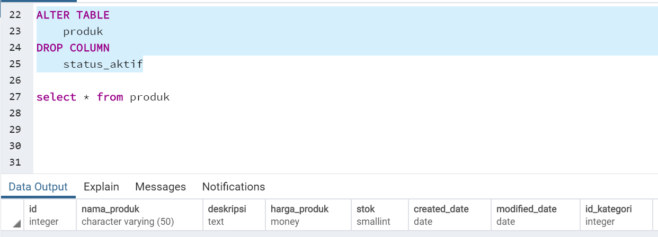

* Add status_aktif default ‘Aktif’

|  |
| --- |
| ALTER TABLE  produk  ADD COLUMN  status_aktif varchar(20) DEFAULT 'Aktif'    select * from produk |

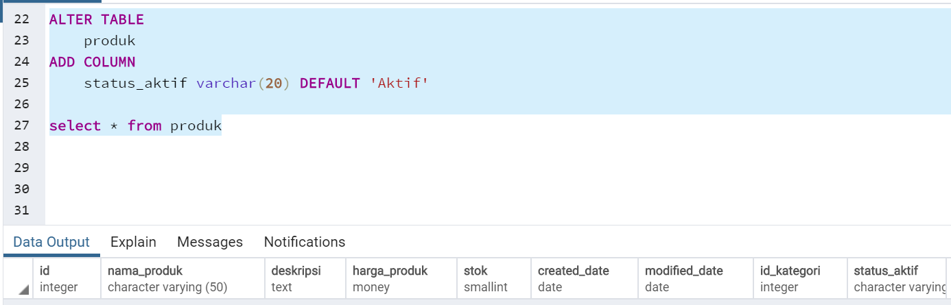

|  |
| --- |
| ALTER TABLE  kategori  DROP COLUMN  status_aktif |

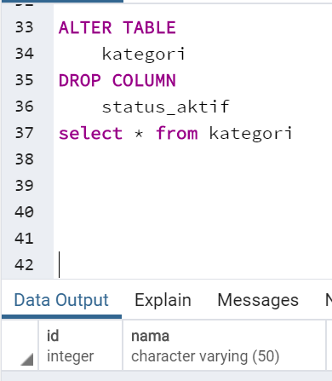

* add column

|  |
| --- |
| ALTER TABLE  kategori  add COLUMN  status_aktif varchar(20) default 'Aktif'  select * from kategori |

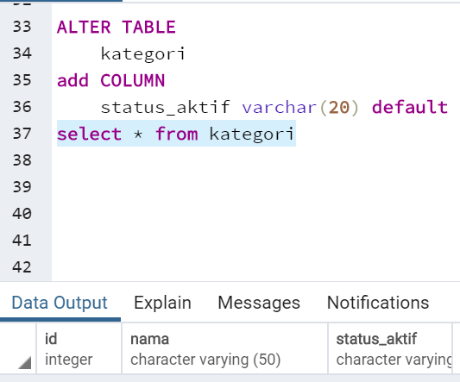

* Insert Data Kategori

|  |
| --- |
| insert into kategori(  nama  )values  ('Handphone'),  ('Laptop'),  ('Pakaian')  select * from kategori |

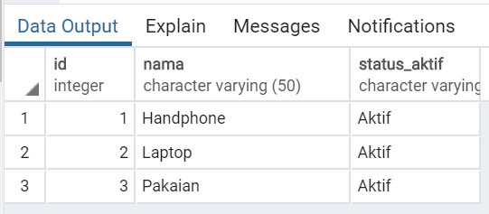

1. Inner Join
   1. Inner join

|  |
| --- |
| select  p.nama_produk,  p.harga_produk,  k.nama,  k.status_aktif  from produk as p  inner join kategori k on (k.id= p.id_kategori)  where k.status_aktif = 'Aktif' |

